VySkan
Product Name | 4G Advanced Fleet & Fuel Tracker
Product Model | VF-Mixer
Precision. Telemetry. Reliability.

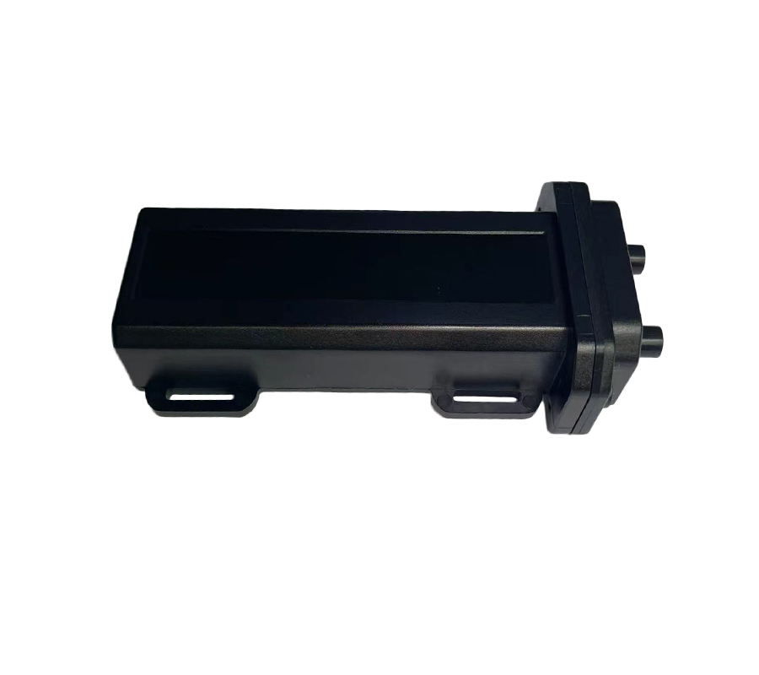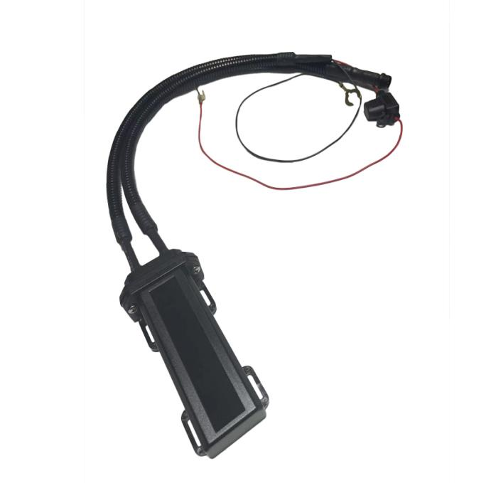

Designed for specialized enterprise fleets and heavy machinery, the VF-Mixer delivers far more than basic location tracking. It resolves complex operational blind spots by deeply monitoring fuel consumption, payload weight, and specialized equipment status. It is the ultimate telematics tool for logistics trucks, concrete mixers, and industrial vehicles requiring rich data extraction.

Core Value
- Advanced Fuel & Payload Telemetry
Supports seamless integration with external sensors to monitor real-time fuel consumption, detect fuel theft/leaks, and measure cargo weight. It transforms raw vehicle data into actionable ROI for fleet managers.
- Specialized Equipment Monitoring
Features unique forward/reverse rotation detection (ideal for concrete mixer trucks) and precise working hour statistics for heavy machinery.
- Zero Data Loss Guarantee
Built-in massive flash memory automatically stores up to 30,000 historical records during cellular blind spots. Data is seamlessly uploaded once the connection is restored, ensuring 100% route and telemetry integrity.

Target Applications
- Heavy-Duty Logistics & Freight (Fuel & Payload Monitoring)
- Construction & Concrete Mixers (Drum Rotation & Work Hours)
- Cold Chain Transportation (Temperature & Humidity Sensing)
- Industrial Equipment & Machinery (Asset Utilization)
- Technical Specifications
3.1 Cellular & GNSS
Category | Specification | Description
Network Bands | 4G FDD-LTE (B1/B3)  4G TDD-LTE (B38/B39/B40/B41)  (Optional) | Broad 4G coverage for uninterrupted data transmission.
GNSS Module | GPS + BDS Dual-mode | High-performance tracking with AGPS support.
Positioning Accuracy | 5 meters | Pinpoint precision for real-time tracking.
Sensitivity | -165 dBm | Maintains lock in challenging and dense environments.
OTA Support | TFTP Remote Upgrade | Supports remote parameter configuration and firmware upgrades.
3.2 Power & Electrical
Category | Specification | Description
Operating Voltage | DC 9V - 45V | Wide voltage range compatible with both light and heavy-duty vehicles.
Standby Current | < 50 mA | Low power consumption to protect vehicle batteries.
Backup Battery | 4.2V / 180mAh Li-ion (Optional) | Triggers main power-loss alarms for active defense.
3.3 Interfaces & Expandability
Category | Specification | Description
Ignition Detection | ACC ON/OFF | Real-time monitoring of vehicle start/stop status.
Fuel Monitoring | Supported | Integrates with fuel sensors to detect refuels, drops, and consumption.
Payload Sensing | Supported | Integrates with weight sensors for cargo monitoring.
Rotation Sensor | Supported | Detects forward, reverse, and stop statuses (crucial for cement mixers).
Temp/Humidity | Supported | Environmental monitoring for cold chain operations.
3.4 Physical & Environmental
Category | Specification | Description
Dimensions | 103mm × 32mm × 18mm | Highly modular and compact design.
Weight | 70g | Lightweight construction.
Operating Temp. | -20℃ to +70℃ | Reliable operation in varied climates.
Storage Temp. | -40℃ to +85℃ | Safe storage in extreme conditions.
Operating Humidity | 5% - 95% RH | Resilient in humid environments.

Built for Rapid Integration & Telemetry
We know hardware is only half the solution. The VF-Mixer is designed to drastically reduce your Time-to-Market (TTM) and development costs.
- Standard Protocols: Natively supports TCP/IP and the industry-standard GT06 protocol.
- Supported Platforms: Seamlessly integrates with industry-leading tracking software including Wialon, Traccar, and enterprise custom dashboards without reverse engineering.
- Advanced Sensor Parsing: Comprehensive Open API documentation helps your IT team effortlessly parse not just GPS coordinates, but deep telemetry data (fuel, rotation, payload, temperature), achieving live dashboard connectivity in under 48 hours.
- A personalized service prepared for you
- 1× VF-Mixer Sample Device (Pre-configured)
- Full API & Protocol Documentation
- 1-on-1 Technical Support from our Field Engineers
- Contact us
Website：https://vyskan.com/
Email: marketing@vyskan.com

